PROJECT DEVELOPMENT PHASE

SPRINT – 3

TEST CASE

|  |  |
| --- | --- |
| Date | 09-Nov-2022 |
| Team ID | PNT2022TMID17753 |
| Project Name | DEVELOPING A FLIGHT DELAY MODEL USING MACHINE LEARNING |
| Maximum Marks | 8 MARKS |

PREDICTION VALUE = 1 (FLIGHT IS DELAYED)

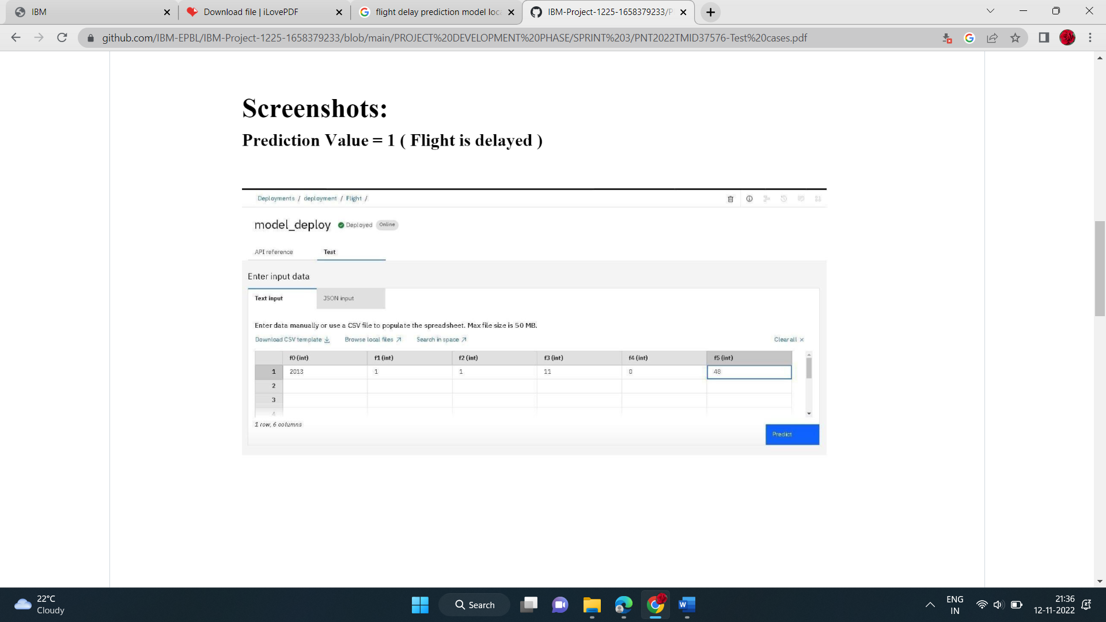

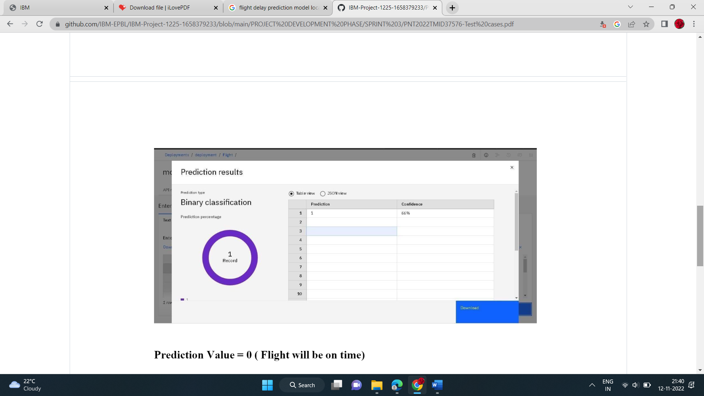

PREDICTION VALUE = 0 (FLIGHT WILL BE ON TIME)

